Infosys Springboard Virtual Internship 7.0
Completion Report
Team Details: Team D
Batch Number: Batch – 1
Start Date: 02/06/2026
Names: Vennela Pathipaka, Subhashree Subhasmita, Tejasri Lakshmi Maddula, Twinkle Mohanty.
Internship Duration: 8 Weeks

- Project Title
Cyber Threat Analytics Platform with Incident Visualization System
Group - 1
- Project Objective
The objective of this project phase is to understand the cybersecurity dataset, connect it with Power BI, perform data preprocessing by handling missing values, removing duplicates, and correcting data types, and prepare a clean and structured dataset for creating meaningful visualizations and supporting cybersecurity incident analysis.

- Project Description
  - Overview
This project focused on analysing a cybersecurity incident dataset using Power BI. The dataset was connected to Power BI, where preprocessing tasks such as handling missing values, removing duplicate records, correcting data types, and cleaning irrelevant data were performed to improve data quality. The processed dataset was then prepared for visualization, enabling meaningful analysis of cyber threats, attack patterns, affected countries, and incident trends. The project provides a structured foundation for creating interactive dashboards that support cybersecurity monitoring and data-driven decision-making.

  - Project Approach

Step 1: Problem Understanding
The project objectives for Milestone 3 were reviewed to understand the requirement of extending the existing cybersecurity dashboards with additional interactive visualizations.

Step 2: Dataset Review and Understanding
The previously pre-processed cybersecurity dataset was analysed to understand its structure, attributes, and existing dashboard components for further enhancement.

Step 3: Data Connection
The dataset was connected to Microsoft Power BI, and the existing data model was verified to ensure accurate data loading and relationships.

Step 4: Data Validation
The cleaned dataset was validated by checking data consistency, calculated measures, and required fields to support the new dashboard development.

Step 5: Data Modeling
Necessary DAX measures, calculated columns, and relationships were created or refined to enable advanced analysis and improve dashboard performance.

Step 6: Dashboard Development
Three new interactive dashboards were developed using Power BI by incorporating various visualizations such as charts, maps, KPI cards, slicers, and filters to present cybersecurity insights effectively.

Step 7: Dashboard Testing and Validation
Each dashboard was tested to ensure that visualizations, calculations, filters, and interactions displayed accurate and consistent results. Necessary refinements were made to improve usability.

Step 8: Report Documentation and Presentation
The completed dashboards were documented with screenshots, observations, and key findings. The project implementation and outcomes were then compiled into the internship completion report.

  - Technology Used
This project was implemented using Microsoft Power BI to analyze and visualize cybersecurity incident data through interactive dashboards. The dataset was imported into Power BI, where Power Query Editor was used for data preparation and validation. DAX (Data Analysis Expressions) was utilized to create calculated measures and support advanced analytical requirements. Various interactive visualizations, including cards, bar charts, column charts, treemaps, maps, funnel charts, ribbon charts, KPI cards, and slicers, were designed to present cybersecurity trends and incident patterns effectively.
Technology/Tool | Purpose
Microsoft Power BI | Dashboard development and data visualization
Power Query Editor | Data preparation and validation
DAX (Data Analysis Expressions) | Creating calculated measures and KPIs
Cybersecurity Incident Dataset (CSV) | Source of cybersecurity incident data
Interactive Visualizations | Displaying trends, attack patterns, and insights
Microsoft Windows | Development environment

3.4 Insights from the Dashboard
The interactive dashboards provided valuable insights into cybersecurity incidents by presenting data in a clear and meaningful manner. The analysis revealed the distribution of cyberattacks across different countries, attack types, attacker origins, asset roles, and time periods. Hacking emerged as one of the most frequently observed attack methods, while external threat actors were responsible for a significant number of incidents. Geographic visualizations highlighted countries with higher incident frequencies, enabling a better understanding of regional cybersecurity risks.
The dashboards also identified trends in attack patterns over time, allowing users to observe changes in incident frequency and the ranking of different attack types. Interactive filters and slicers enabled detailed exploration of the dataset, making it easier to compare multiple categories and identify critical areas requiring attention. Overall, the dashboards transformed complex cybersecurity data into meaningful visual insights, supporting efficient monitoring, informed decision-making, and strategic planning for improving cybersecurity awareness and incident management.

3.5 Real-world Impact for Media and Public Communication
- Improves the understanding of cybersecurity incidents through interactive and easy-to-read dashboards.
- Helps organizations identify cyberattack trends and make informed security decisions.
- Enables quick analysis of attack patterns, targeted countries, and affected assets.
- Supports security teams in monitoring incidents and planning preventive measures.
- Assists media professionals in presenting cybersecurity statistics and trends in a clear visual format.
- Increases public awareness of cybersecurity threats and the importance of digital safety.
- Simplifies complex cybersecurity data, making it understandable for both technical and non-technical audiences.
- Encourages data-driven decision-making by providing accurate and interactive visual insights.
- Enhances communication between organizations, researchers, and stakeholders through meaningful visual reports.
- Contributes to better cybersecurity planning and incident management using business intelligence dashboards.

- Timeline Overview
Week | Activities Planned | Activities Completed
Week1 | Understand project & prepare PPT | Project understanding and PPT completed
Week2 | Collect the cybersecurity dataset and perform data preprocessing for visualization. | Collected the dataset, cleaned the data, handled missing values, and prepared it for analysis in Power BI.
Week3 | Develop the first two interactive Power BI dashboards. | Designed and completed Dashboard 1 and Dashboard 2 with interactive visualizations and insights.
Week4 | Develop three additional Power BI dashboards for enhanced analysis. | Dashboard 3, Dashboard 4 & 5 completed
Week5 | Analyze dashboard insights and identify cybersecurity threat patterns. | Analyzed attack patterns, threat trends, attacker behaviour, asset targeting, and attack motives using the developed Power BI dashboards.
Week6 | Develop two additional Power BI dashboards for advanced threat pattern analysis. | Dashboard 6 and Dashboard 7 completed with visualizations for attack patterns, threat trends, attacker behaviour, asset targeting, and attack motives.
Week7 | Testing, Validation, Refinement | Tested and validated dashboards, checked calculations, filters, visual interactions, and refined the dashboards based on observations.
Week8 | Documentation and Final Presentation. | Completed project documentation, finalized the report and PPT, and prepared the final presentation.

5a. Key Milestones
Milestone | Description | Date Achieved
Milestone 1 | Data Foundation & Preparation – Dataset collection, preprocessing, cleaning, and data validation. | 9/06/2026
Milestone 2 | Core Dashboard Development – Built the first two interactive Power BI dashboards for cybersecurity analysis. | 16/07/2026
Milestone 3 | Advanced Visualization & Reporting – Created three additional dashboards, generated insights, and completed project documentation. | 23/07/2026
Milestone 4 | Created two additional interactive Power BI dashboards to perform deeper cybersecurity threat pattern analysis and generate additional insights. | 13/08/2026

Milestone 1:
Identified the cybersecurity analysis problem and defined the main objectives of the project. Collected a suitable cybersecurity incident dataset and studied its structure, attributes, data types, and relevant fields. The dataset was reviewed to understand the information available for further analysis.

Milestone 2:
Imported the collected dataset into Microsoft Power BI and performed data cleaning and transformation using Power Query. Removed unnecessary columns, handled missing values, removed duplicate records, and corrected data types. The cleaned dataset was validated and prepared for visualization and analysis.

Milestone 3:
Created the required data model and DAX measures to support cybersecurity analysis. Developed the first set of interactive Power BI dashboards using charts, KPI cards, slicers, and other visualizations. Analyzed important aspects such as attack types, attacker countries, targeted assets, and attack motives to generate meaningful insights.

Milestone 4:
Developed two additional Power BI dashboards for deeper cybersecurity analysis. The dashboards focused on attack patterns, threat trends, attacker behaviour, asset targeting, attack techniques, and threat motives. Added interactive filters for attributes such as country and motive, along with different visualizations to identify important patterns and trends. The dashboards were reviewed and refined to ensure clear presentation, accurate results, and useful cybersecurity insights.

5b. Project Execution details
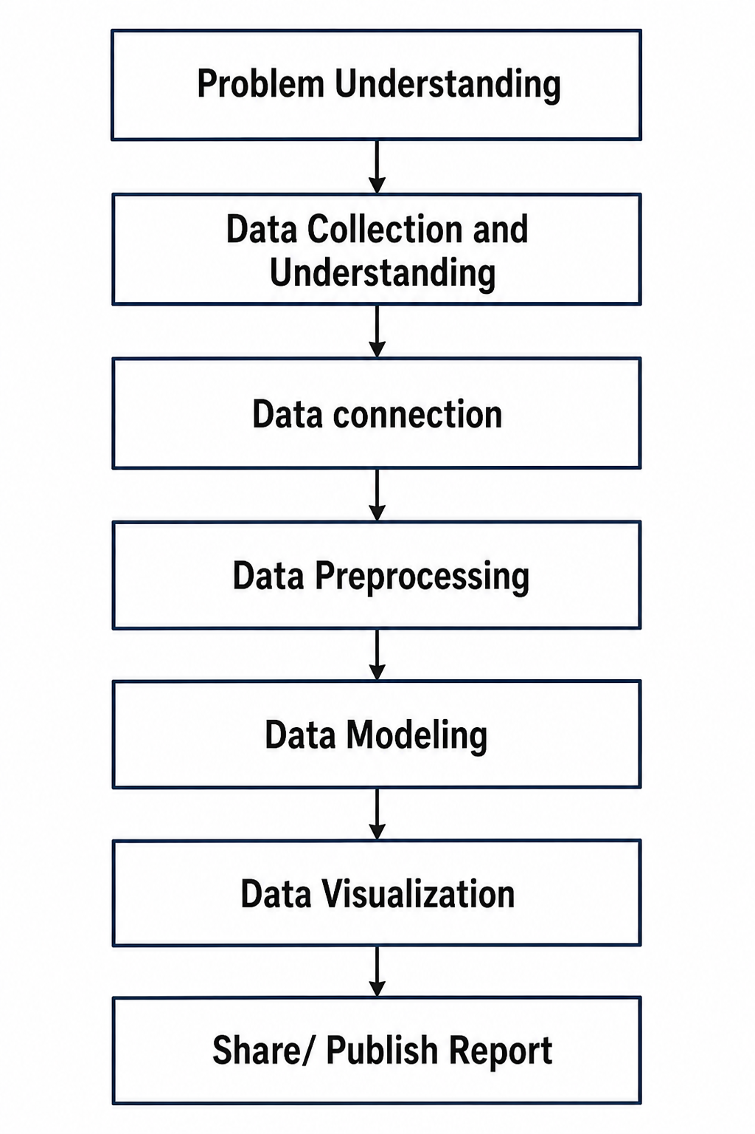
Step 1: Problem Understanding
The project objectives and requirements were analyzed to understand the cybersecurity problem and identify the key goals for data analysis and dashboard development.
Step 2: Data Collection and Understanding
The cybersecurity incident dataset was collected in CSV format from a publicly available source. Before starting the analysis, the dataset was carefully examined to understand its overall structure, including the number of records, columns, and the type of information contained in each attribute. The dataset included details such as actor variety, asset variety, attack motive, attacker country, victim country, attack type, day, month, year, and other incident-related attributes.
The dataset was then explored to identify:
- The total number of rows and columns.
- The purpose of each attribute.
- Numerical, categorical, and date fields.
- Missing (NA) values and unknown entries.
- Unnecessary columns that were not useful for analysis.
- Duplicate or inconsistent records that required cleaning.
Step 3: Data Connection
The collected dataset was imported into Microsoft Power BI Desktop using the Get Data → Text/CSV option. After importing, the dataset was loaded into the Power Query Editor, where the data transformation process was carried out.
- Promoted the first row as column headers.
- Verified and corrected the data types of all attributes.
- Removed unnecessary columns.
- Renamed column names for better readability.
- Cleaned text fields by removing unwanted characters.
- Trimmed extra spaces from text values.
- Standardized text formatting by capitalizing words.
- Replaced invalid or inconsistent values such as NA where required.
- Filtered unwanted rows and retained valid records.
- Reordered and sorted columns to improve dataset organization.
- Loaded the cleaned dataset into Power BI's data model for visualization.
After completing these transformations, the dataset became clean, consistent, and ready for creating interactive dashboards and performing cybersecurity incident analysis.
Step 4: Data Preprocessing
The dataset was cleaned by handling missing values, removing duplicate records, correcting data types, and preparing the data for accurate analysis and visualization.
Source
- Imported the cybersecurity incident dataset into Power BI.
Promoted Headers
- Converted the first row of the dataset into column headers.
Changed Data Types
- Assigned appropriate data types (Text, Number, Date) to each column for accurate analysis.
Removed Unnecessary Columns
- Deleted irrelevant columns that were not required for the analysis to improve performance.
Renamed Columns
- Renamed column headers to meaningful and easy-to-understand names.
Capitalized Each Word
- Standardized text values by converting them into proper case for consistency.
Replaced Values
- Replaced invalid, missing, or inconsistent values (such as NA or unwanted values) with appropriate values.
Cleaned Text
- Removed non-printable and unwanted characters from text fields.
Trimmed Text
- Eliminated leading and trailing spaces to ensure consistent text formatting.
Filtered Rows
- Removed unwanted rows and retained only valid records required for analysis.
Reordered Columns
- Rearranged the columns into a logical sequence to improve readability and simplify data processing.

Sorted Rows
- Sorted the dataset to organize records in a structured order.
Final Validation
- Verified the cleaned dataset to ensure data accuracy, consistency, and readiness for dashboard creation.
Step 5: Data Modeling
Relationships, calculated measures, and DAX expressions were created to organize the data model and support efficient reporting and analytical insights.
Step 6: Data Visualization
Interactive dashboards were developed using Power BI visualizations such as cards, charts, maps, treemaps, slicers, and KPIs to present cybersecurity trends and insights effectively.
Step 7: Share / Publish Report
The completed dashboards and report were reviewed, documented, and prepared for presentation and submission, enabling stakeholders to access and interpret the analytical results.

Dashboard 1: Executive Summary
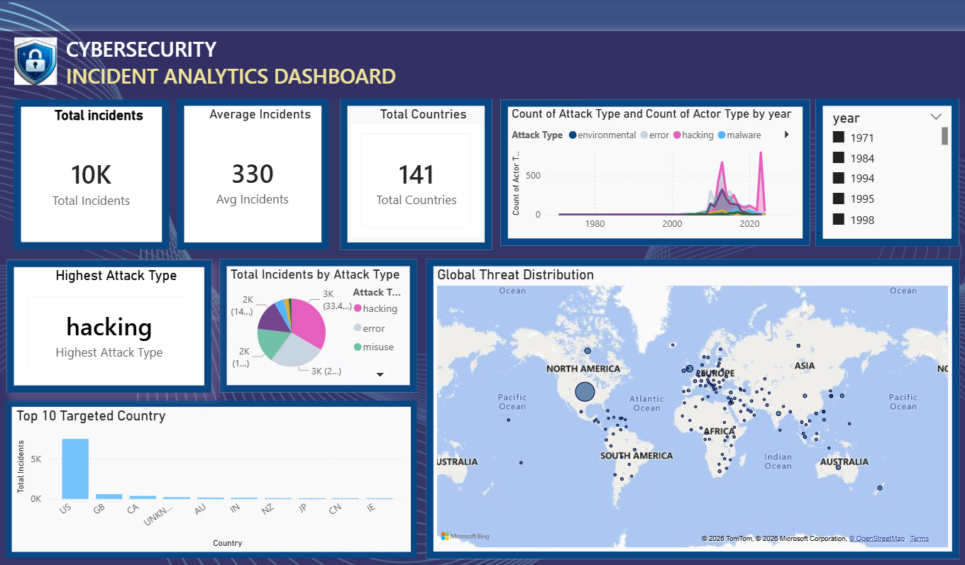
1.1 Total Incidents
A KPI card displays the total number of cybersecurity incidents (10K). It provides an immediate overview of the incident volume and serves as the primary performance indicator of the dashboard.
1.2 Average Incidents
A KPI card displays the average number of incidents as 330. This provides an understanding of the average incident volume and helps summarize the overall distribution of cybersecurity incidents in the dataset.
1.3 Total Countries
A KPI card displays that incidents were reported across 141 countries, highlighting the global nature of cybersecurity threats.

1.4 Attack and Actor Trend by Year
A combined chart illustrates the yearly trend of cybersecurity incidents based on attack types and actor types. The chart shows that incidents remained relatively low in the earlier years, followed by a significant increase after the 2000s, with major peaks during the 2010–2020 period. This helps analyze how different attack categories and actors contributed to the growth of cyber incidents over time.

1.5 Year slicer
An interactive Year slicer allows users to filter the dashboard based on a specific year or a range of years. When a year is selected, the other visuals update dynamically to display cybersecurity incidents for the selected time period. This enables users to analyze changes in attack types, incident counts, targeted countries, and global threat distribution over different years.

1.6 Highest Attack Type
Highlights the attack type with the highest number of incidents in the dataset, allowing users to quickly identify the most common cybersecurity threat.
1.7 Total incidents by Attack Type
Shows the distribution of incidents across different attack types. It helps compare the proportion of each attack category and identify the most prevalent threats.

1.8 Top 10 Targeted Countries
A vertical bar chart ranks the countries with the highest number of cybersecurity incidents. The United States records the highest number of incidents, followed by other countries, while the "Unknown" category indicates incidents with unidentified locations.


1.9 Global Threat Distribution
A bubble map visualizes the geographical distribution of cybersecurity incidents worldwide. Larger bubbles represent regions with higher incident counts, making it easier to identify global threat hotspots.

Dashboard 2: Threat Analysis
The Threat Analysis page provides detailed insights into attack behaviour, threat actors, motives, and historical trends.
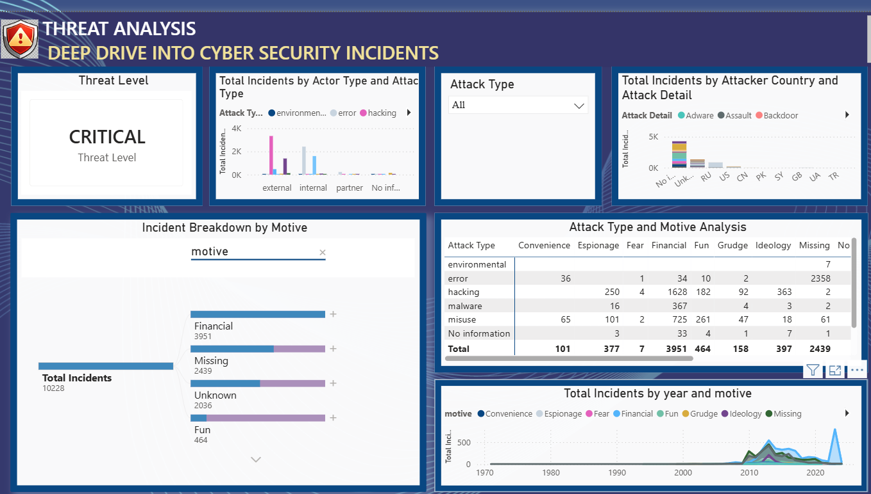
2.1 Threat Level
A KPI card displays the overall Threat Level as Critical, indicating the severity of the cybersecurity incidents analysed in the dataset and highlighting the importance of monitoring and analysing these threats.
2.2 Actor Type vs Attack Type
A grouped bar chart compares attack types across External, Internal, Partner, and Unknown actors. External actors account for the highest number of incidents, while internal and partner-related threats also contribute significantly.

2.3 Attack Type Slicer
An interactive slicer enables users to filter the dashboard by attack type. Selecting a specific category updates all visuals dynamically, allowing focused analysis.
2.4 Incidents by Attacker Country
Displays the total number of cybersecurity incidents by attacker country, categorized by attack details. This visualization helps identify the countries associated with higher attack activity and compare the distribution of different attack details.

2.5 Decomposition Tree
The decomposition tree breaks down total incidents into individual attack categories, allowing users to drill down into detailed information and perform interactive analysis.

2.6 Attack Type vs Motive Matrix
A matrix visual compares attack types with attacker motives. Financially motivated hacking records the highest number of incidents, followed by financially motivated physical attacks, highlighting the primary drivers behind cyber threats.
2.7 Incident Trend by Motive
A stacked area chart displays the trend of cybersecurity incidents over time based on attacker motives. The chart shows a steady increase in incidents after 2005, with significant growth after 2010, demonstrating the rising complexity and frequency of cyber threats.
Dashboard 3: Attacker and actor Intelligence
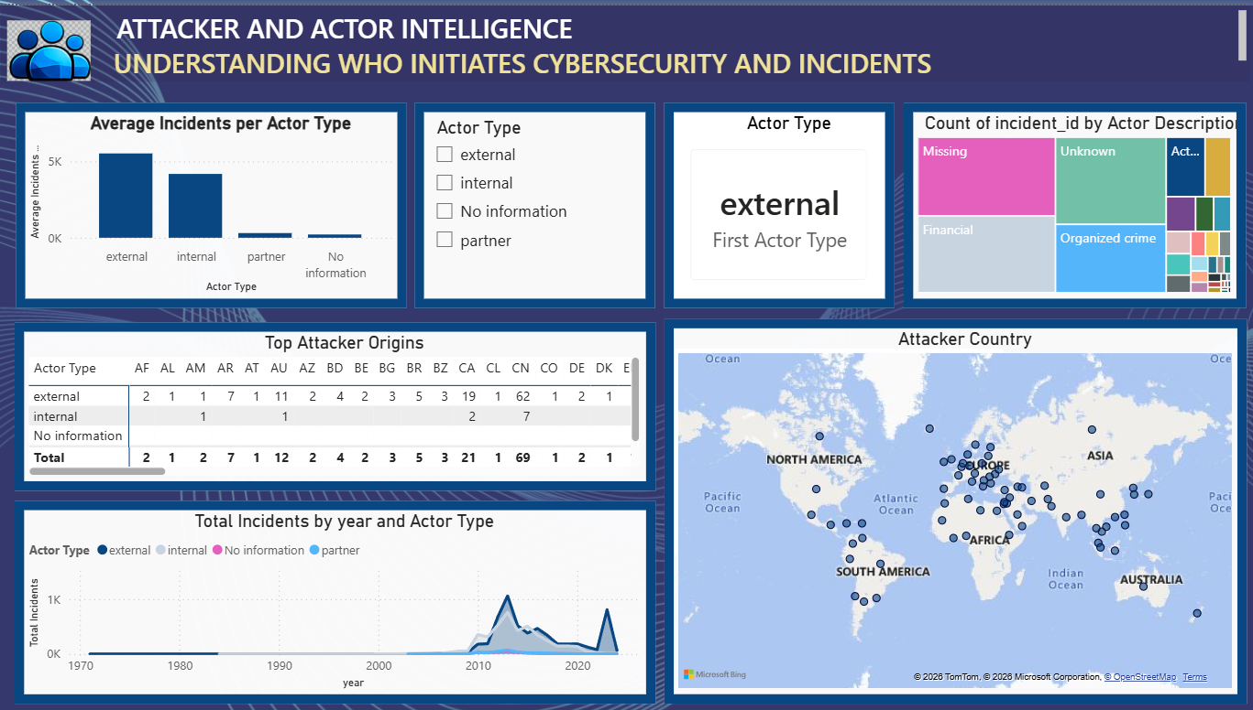
3.1 Average Incidents per Actor Type
Displays the average number of cybersecurity incidents for each actor type, helping compare the level of activity among external, internal, partner, and unknown actors.
3.2 Actor Type
Allows users to filter the dashboard by a selected actor type, enabling focused analysis of incidents associated with specific actors.

3.3 Actor Type
Displays the selected actor type based on the slicer, providing a quick summary of the current dashboard filter.
3.4 Count of Incident ID by Actor Description
Shows the distribution of cybersecurity incidents based on actor descriptions. The size of each block represents the number of incidents, making it easy to identify the most common attacker categories.


3.5 Top Attacker Origins
Displays the distribution of actor types across different attacker countries, helping identify the primary origins of cybersecurity incidents.

3.6 Attacker Country
Visualizes the geographical locations of attacker countries, providing a global view of where cybersecurity incidents originate.

3.7 Total Incidents by Year and Actor Type (Area Chart)
Illustrates the yearly trend of cybersecurity incidents for different actor types, helping users analyze how attacker activity has changed over time.
Dashboard 4: Target and asset Vulnerability Analysis
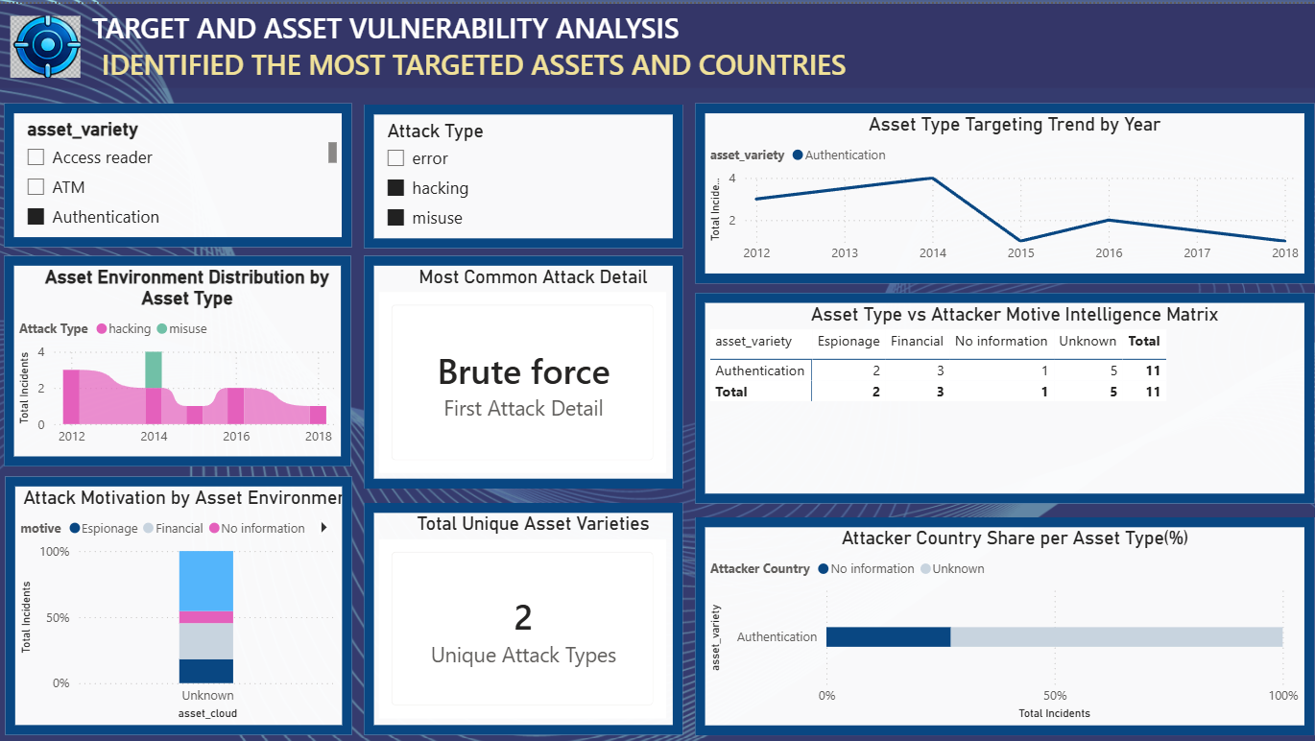
4.1 Asset Variety Filter: Allows users to filter the analysis based on asset types such as Authentication, ATM, and Access Reader.
4.2 Attack Type Filter: Provides filtering based on attack categories such as hacking, misuse, and error.

4.3 Asset Type Targeting Trend by Year: Shows how frequently the selected asset type was targeted from 2012 to 2018. The highest targeting was observed around 2014, followed by a decline.

4.4 Asset Environment Distribution by Asset Type: Displays the distribution of attack incidents across different years and attack types. Hacking appears as a major attack type.
4.5 Most Common Attack Detail: Identifies Brute Force as the most common attack detail in the selected data.

4.6 Asset Type vs Attacker Motive Matrix: Shows the relationship between the asset type and attacker motives such as Espionage, Financial, No Information, and Unknown.

4.7 Attack Motivation by Asset Environment: Represents the percentage distribution of attacker motives. A significant portion of the incidents has an Unknown motive.
4.8 Total Unique Asset Varieties: Shows 2 unique attack types in the selected dataset.

4.9 Attacker Country Share per Asset Type: Compares the contribution of known and unknown attacker countries for the selected asset. The visualization shows a large share of incidents associated with Unknown attacker information.
Dashboard 5: Impact and incident Severity
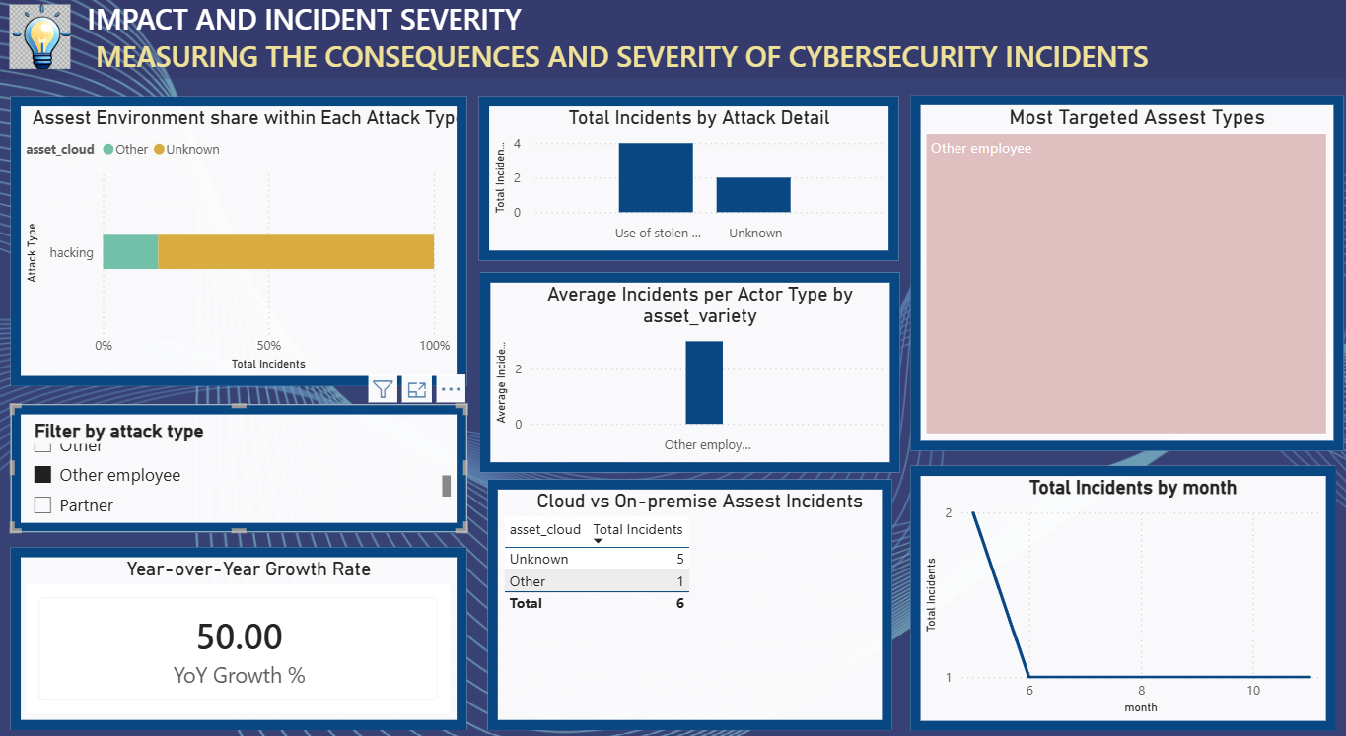
5.1 Asset Environment Share within Each Attack Type
Displays the percentage distribution of asset environments across different attack types, helping identify which environments are most affected by cybersecurity incidents.
5.2 Total Incidents by Attack Detail
Shows the total number of incidents for each attack detail, helping identify the most frequently occurring attack methods.
5.3 Most Targeted Asset Types
Highlights the asset types that experience the highest number of cybersecurity incidents, making it easy to identify the most targeted assets.
5.4 Filter by Attack Type
Allows users to filter the dashboard based on the selected attack type for focused analysis.

5.5 Average Incidents per Actor Type by Asset Variety
Displays the average number of incidents for each actor type across different asset varieties, enabling comparison of attack activity.
5.6 Cloud vs On-premise Asset Incidents
Compares the total number of incidents affecting cloud, on-premise, and other asset environments to evaluate their impact.
5.7 Year-over-Year Growth Rate
Displays the annual percentage change in cybersecurity incidents, indicating the growth or decline in attack frequency.

5.8 Total Incidents by Month
Shows the monthly trend of cybersecurity incidents, helping identify periods with higher or lower attack activity.

Dashboard 6: Threat Pattern Deep Drive
6.1 Peak Threat Year
Shows 2013 as the most dangerous year, indicating the highest level of recorded threat activity.
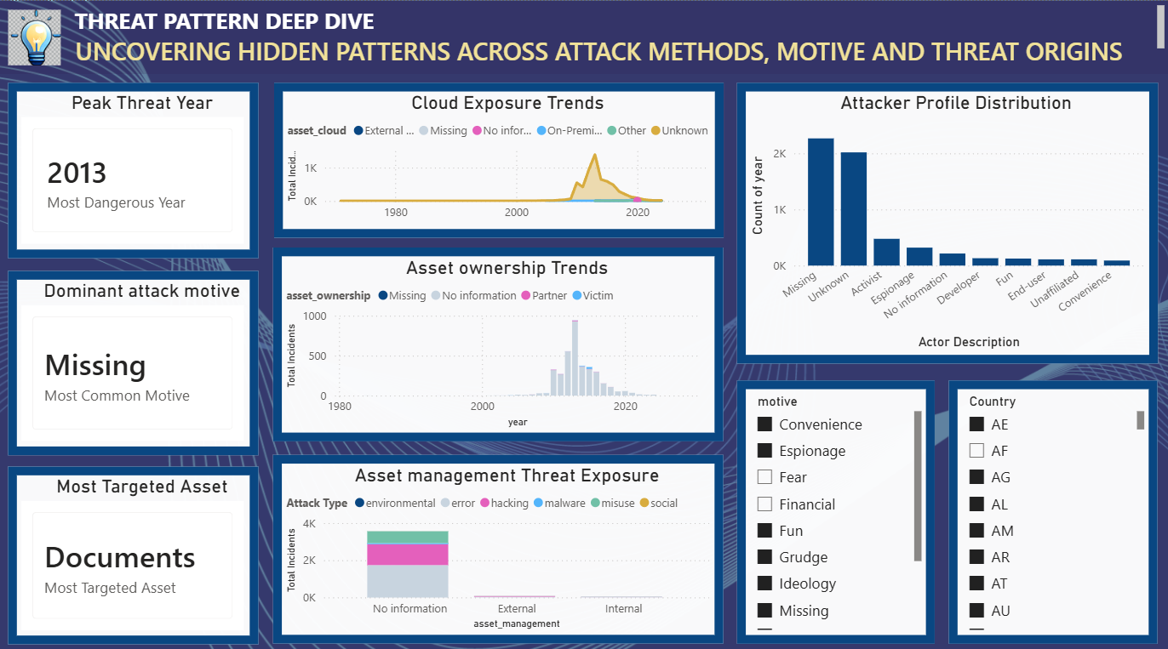
6.2 Dominant Attack Motive
Missing is the most common motive, showing that the reason behind many attacks was not recorded or available.

6.3 Most Targeted Asset
Documents are identified as the most targeted asset, indicating that document-related resources were frequently involved in the recorded incidents.
6.4 Cloud Exposure Trends
Shows changes in cloud-related exposure over time. The graph indicates a significant rise in exposure during the later years, followed by a decline.

6.5 Asset Ownership Trends
Shows the distribution of asset ownership categories such as Missing, No Information, Partner, and Victim across different years. Missing ownership information is prominent.
6.6 Attacker Profile Distribution
Shows the distribution of attacker profiles. Missing and Unknown attacker descriptions have the highest counts, followed by Activist and Espionage.
6.7 Asset Management Threat Exposure
Compares attack types across asset management categories. The No Information category has the highest number of incidents, with hacking and other attack types contributing significantly.
6.8 Motive Filter
Allows users to filter the dashboard based on motives such as Convenience, Espionage, Financial, Fun, Grudge, Ideology, and Missing.
6.9 Country Filter
Allows users to select individual countries and analyse the cybersecurity threats associated with the selected country.

Dashboard 7: Attacker Patter Analysis
7.1 Threat Activity Span
Shows a total activity span of 31 years based on the available incident records. It helps understand cybersecurity threats across different time periods.
7.2 Peak Threat Decade
The 2010s recorded the highest threat activity, showing a significant increase in cyber incidents during this period.
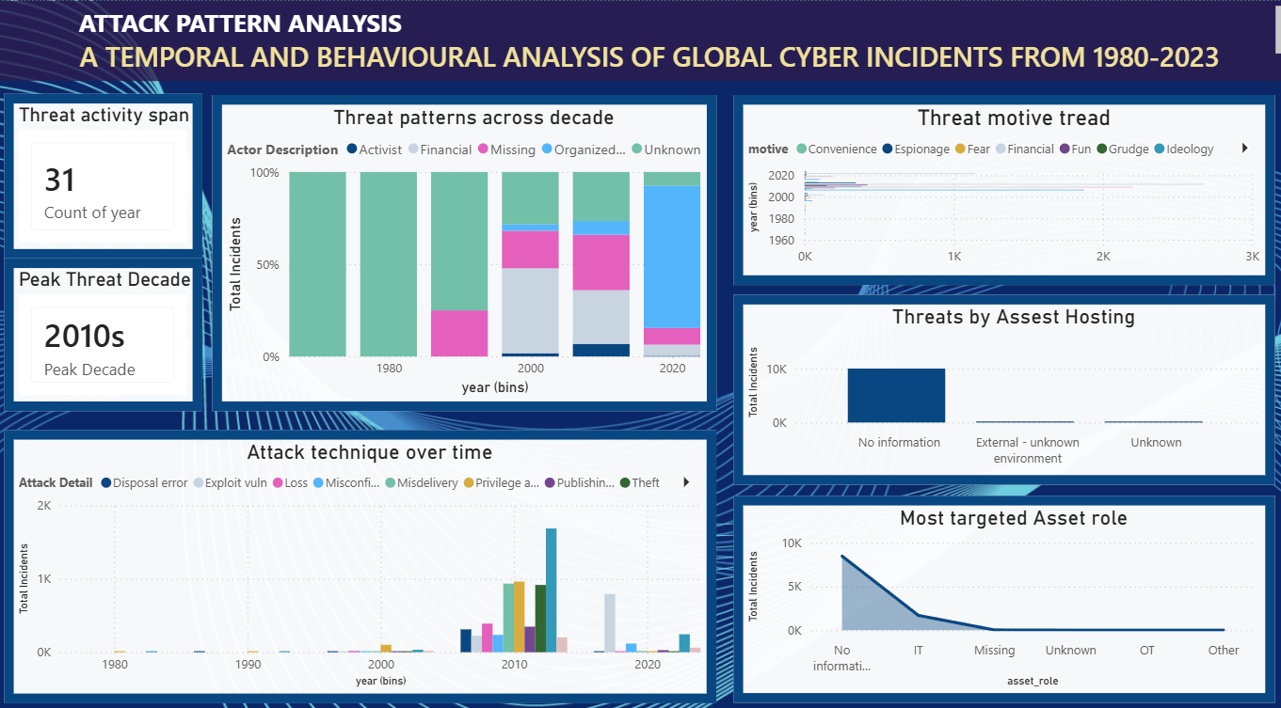7.3 Threat Patterns Across Decades
Shows changes in attacker descriptions across different decades. Unknown and Missing attacker information forms a major portion of the records.
7.4 Threat Motive Trend
Shows how attack motives such as Espionage, Financial, Convenience, Fear, Fun, Grudge, and Ideology varied over time.


7.5 Threats by Asset Hosting
The No Information category has the highest number of incidents, indicating that hosting environment details were unavailable for many records.
7.6 Attack Technique Over Time
Shows the use of different attack techniques across the years. Attack activity increased significantly during the 2010s, with several techniques becoming more common.

7.7 Most Targeted Asset Role
No Information is the most frequently recorded asset role, followed by IT. This shows that detailed information about the targeted asset role was missing in many incidents.

- Snapshots / Screenshots
1)Data Preprocessing
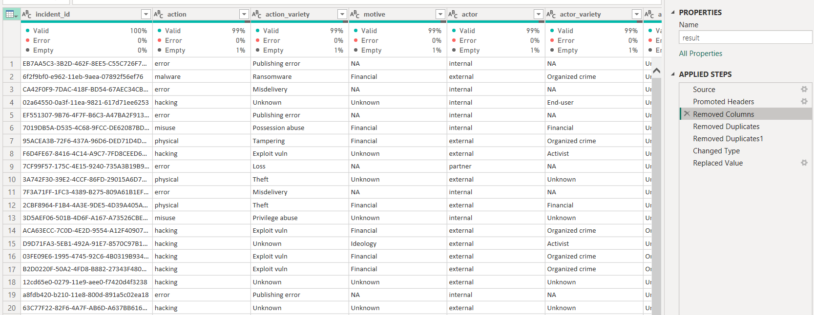
Fig:1.1 Removed Column
The Unnamed: 0 column was removed because it was an automatically generated index column and did not contribute to the cybersecurity analysis. Its removal helped simplify the dataset and improve data quality.

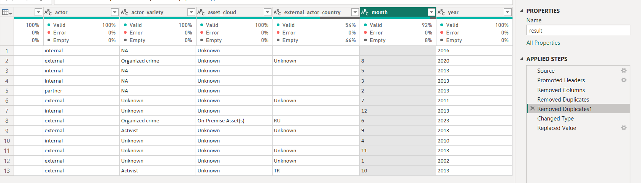
Fig:1.2 Removed Duplicates
Missing values present in the dataset were identified using the Column Quality feature in Power Query Editor. Columns containing empty values were examined, and missing entries were replaced with "Unknown" to maintain data consistency and avoid information loss during analysis.

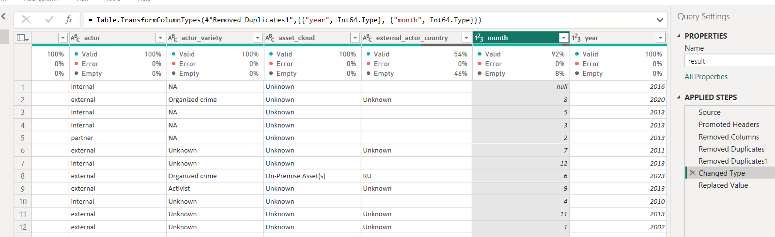
Fig:1.3 Changed types
The data types of all attributes were validated and standardized. Numerical columns such as month and year were converted to whole numbers, while categorical columns were retained as text to support accurate analysis and visualization.
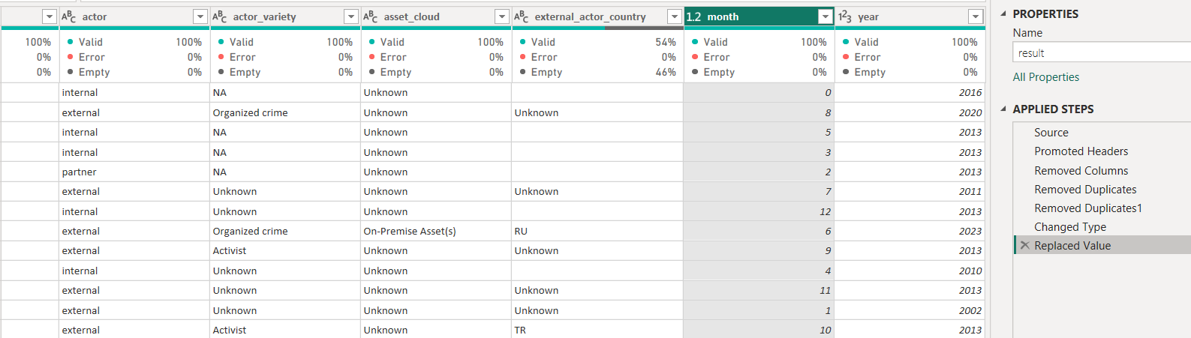
Fig: 1.4 Replaced Value
Missing (null) values in the dataset were replaced with 0 using the Replace Values feature in Power Query Editor. This was done to handle incomplete records, maintain data consistency, and facilitate accurate analysis and visualization.

2) Data Visualisation
 Fig : 2.1 Executive Summary

Fig : 2.2 Threat Analysis

Fig: 2.3 Attacker and actor Intelligence


Fig : 2.4 Target and asset Vulnerability Analysis

Fig : 2.5 Impact and incident Severity

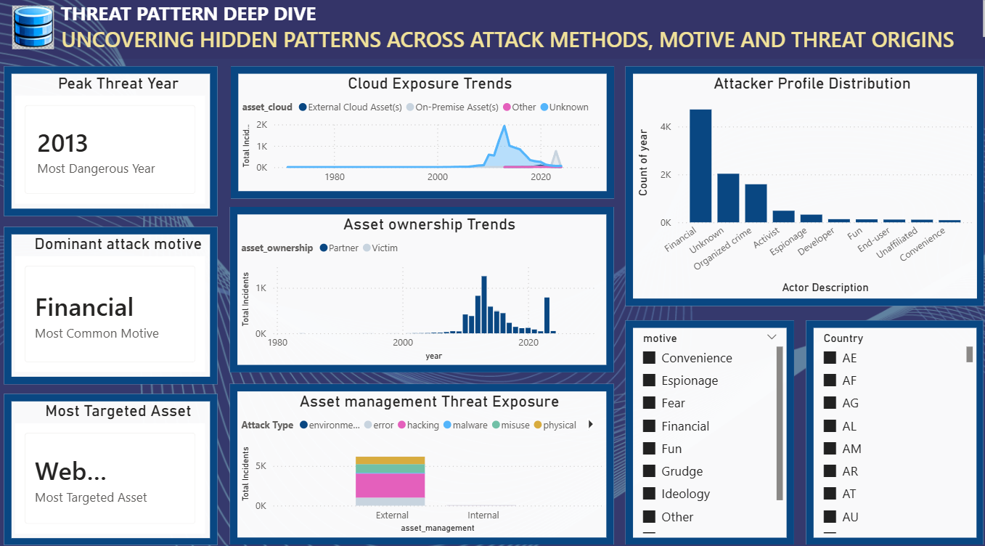
Fig : 2.6 Threat Pattern Deep Drive


Fig: 2.7 Attack Pattern Analysis

7. Challenges Faced
Understanding the cybersecurity dataset – Initially, understanding the large dataset structure, different attributes, and their relationships was challenging. This was resolved by studying the column descriptions and identifying the attributes most relevant to cybersecurity analysis.
Data preprocessing – Handling missing values, duplicate records, inconsistent entries, and unnecessary columns required careful validation. These issues were resolved using Power Query in Microsoft Power BI through data cleaning and transformation steps.
Selecting appropriate visualizations – Choosing suitable charts for different types of cybersecurity information was challenging. Different visualization types were tested and the most meaningful ones were selected to clearly represent trends and comparisons.
Creating DAX measures – Developing calculated measures such as total incidents, averages, and other KPIs required understanding basic DAX functions. This was overcome through practice, testing, and checking the results against the dataset.
Designing multiple dashboards – Creating several dashboards without repeating the same information was challenging. Different themes such as threat patterns, attack techniques, asset targeting, attacker profiles, and motives were used to make each dashboard unique.
Ensuring data accuracy – Dashboard values were checked against the original dataset to ensure that calculations and visualizations were correct. Filters, DAX measures, and chart interactions were also tested before finalizing the dashboards.
Managing dashboard layout – Arranging multiple charts, slicers, cards, and tables in a limited dashboard space required several adjustments. The layout was refined to improve readability and make important information easy to identify.
Creating interactive filters – Implementing filters for attributes such as country, motive, attack type, and asset type required testing to ensure that the visualizations responded correctly to user selections.
8. Learnings & Skills Acquired
8.1 Technical Skills
- Developed interactive dashboards using Microsoft Power BI.
- Gained hands-on experience with Power Query and DAX.
- Created interactive visualizations using charts, maps, and KPI cards.
8.2 Analytical and Problem-Solving Skills
- Analyzed cybersecurity data to identify trends and patterns.
- Improved problem-solving through data preprocessing and dashboard design.
- Enhanced data-driven decision-making skills.
8.3 Future Enhancements
- Integrate real-time cybersecurity data.
- Implement predictive analytics using machine learning.
- Add automated alerts and advanced dashboard features.
8.4 Soft Skills and Team Collaboration
- Improved communication and documentation skills.
- Strengthened time management and analytical thinking.
- Learned to incorporate mentor feedback effectively.
8.5 Domain Knowledge and Application
- Gained knowledge of cybersecurity incidents and attack trends.
- Understood the role of Power BI in cybersecurity analytics.
- Learned the importance of data visualization for decision-making.

9. Testimonials from Team
Team Member 1 – Vennela Pathipaka
- Actively engaged in each milestone of the internship project.
- Supported dashboard enhancement, analysis of results, and final documentation.
- Demonstrated teamwork and commitment throughout the project.
Team Member 2 – Subhashree
- Played an active role throughout all three project milestones.
- Contributed to project planning, dashboard development, and documentation.
- Worked collaboratively to ensure timely completion of project activities.
Team Member 3 – Tejasri
- Participated consistently in every phase of the project.
- Assisted in dataset analysis, Power BI visualization, and report preparation.
- Shared ideas and supported the team in achieving project objectives.
Team Member 4 – Twinkle
- Involved in all stages of the project from planning to implementation.
- Contributed to data preprocessing, dashboard design, and validation.
- Coordinated effectively with the team to complete project deliverables.

10. Conclusion
The Advanced Threat Incident Analytical and Security Visualization Framework project provided valuable practical experience in cybersecurity analytics and data visualization using Microsoft Power BI. Through this internship, I successfully developed interactive dashboards that transformed cybersecurity incident data into meaningful insights. The project enhanced my technical, analytical, and problem-solving skills while strengthening my understanding of business intelligence and data-driven decision-making. Overall, this internship complemented my academic learning and has prepared me for future opportunities in data analytics, cybersecurity, and business intelligence

11. Acknowledgements
We would like to express our sincere gratitude to the Infosys Springboard Team for organizing this highly enriching virtual internship program and for providing a structured, industry-aligned learning platform. The well-designed modules, milestone-based framework, and practical orientation of the internship enabled us to gain meaningful exposure to real-world business intelligence applications.
We extend our heartfelt appreciation to our mentor, Ms. Nityasree, for her consistent guidance, valuable feedback, and continuous encouragement throughout the project lifecycle. Her insights and structured direction played a significant role in shaping the analytical depth and professional quality of this project. We would also like to acknowledge our team members for their strong collaboration, accountability, and shared commitment toward achieving project objectives. The coordinated distribution of responsibilities, open communication, and collective problem-solving approach significantly contributed to the successful execution of this project. In addition, we extend our appreciation to the creators and maintainers of Microsoft Power BI documentation and community resources, which served as essential references during dashboard development and KPI implementation. We are also grateful to Kaggle for providing access to publicly available datasets that facilitated practical, hands-on analytical experience. The structured learning resources and practical exposure provided through this internship have significantly strengthened our analytical thinking, technical proficiency, and business interpretation skills. This experience has enhanced our ability to approach data with a strategic mindset, collaborate effectively within a team environment, and execute projects with professional discipline. Overall, this internship has been a meaningful milestone in our academic and professional journey, reinforcing the value of data-driven decision-making and structured analytical execution in modern business environments.

